

CHAROTAR UNIVERSITY OF SCIENCE AND TECHNOLOGY

FACULTY OF TECHNOLOGY AND ENGINEERING

B. TECH (IT/CE/CSE/AIML)

Subject: Advanced Web Development Frameworks (ITUE301) | Semester: 5th

Practical Statement:
Evaluate the Task Management REST API developed in Practical 4 using the Richardson Maturity Model (Levels 0–3). Identify the maturity level achieved by the API, justify the evaluation based on REST principles, improve the API if required to satisfy at least Level 2, and document the complete evaluation, HATEOAS awareness example, and observations in the MATURITY.md file.

Screenshots:
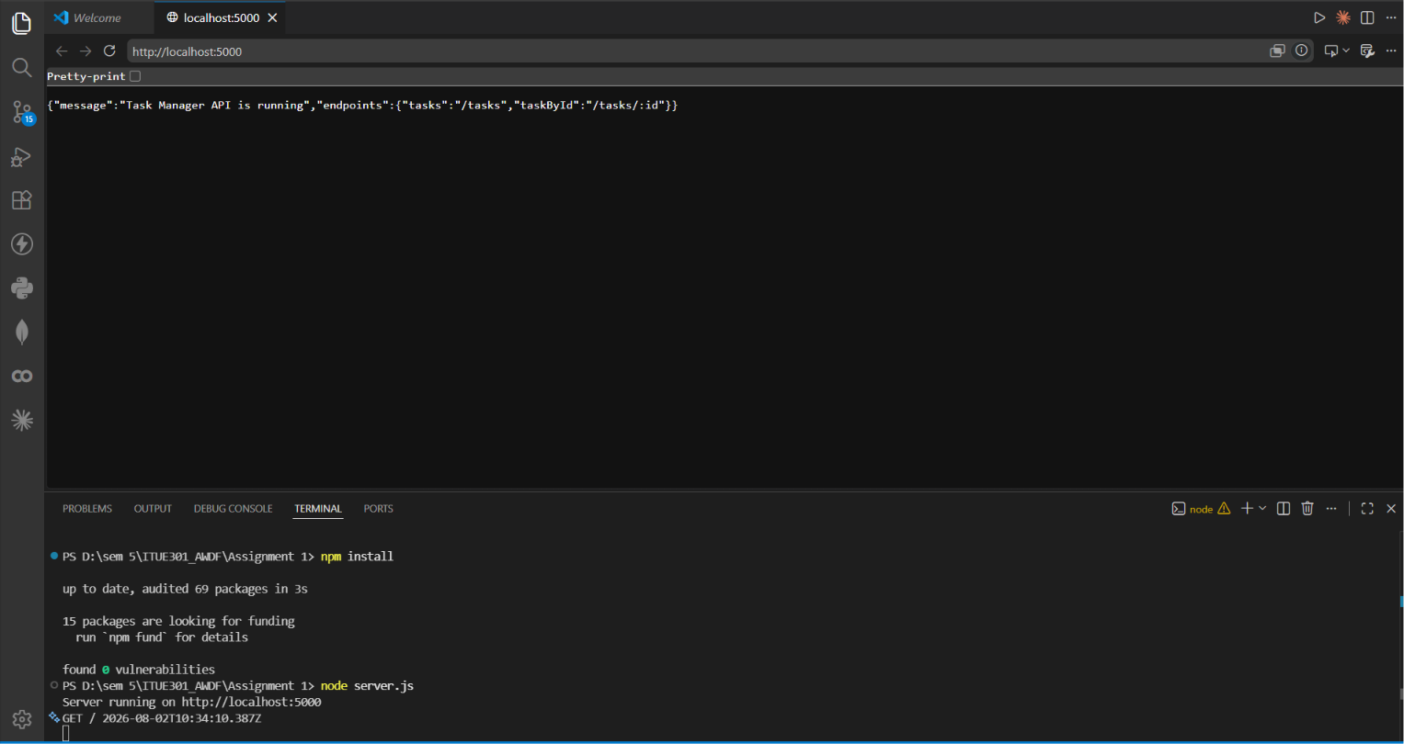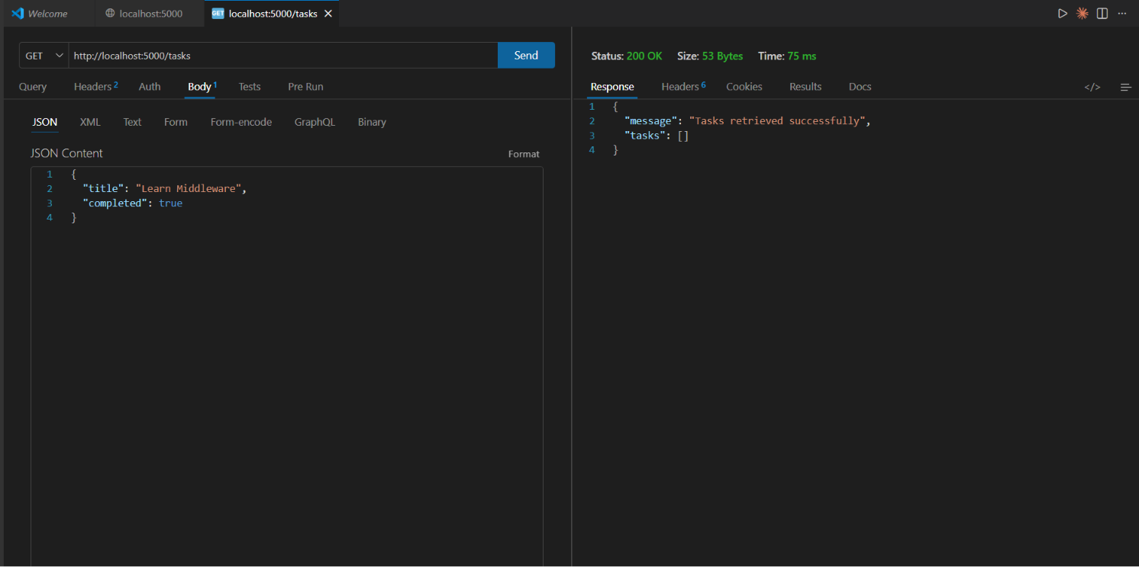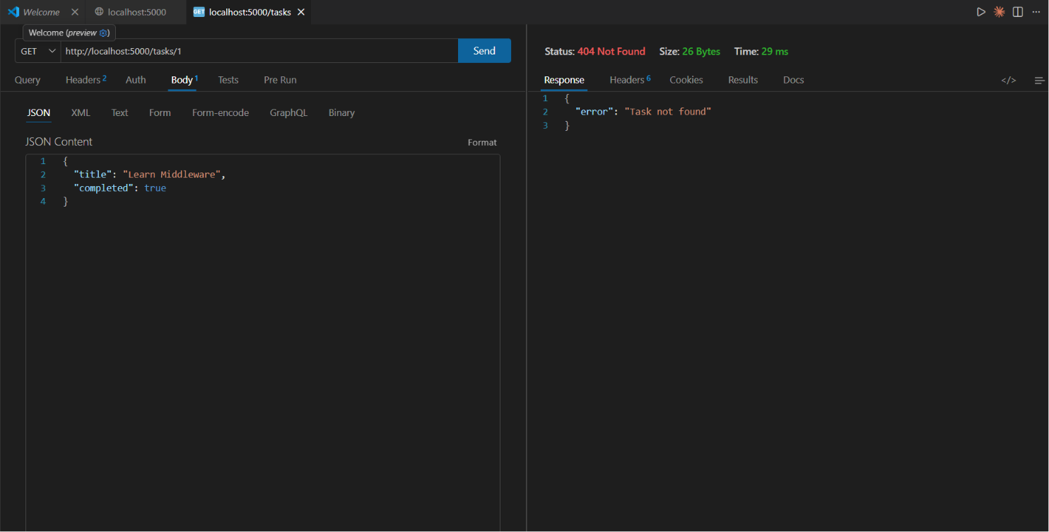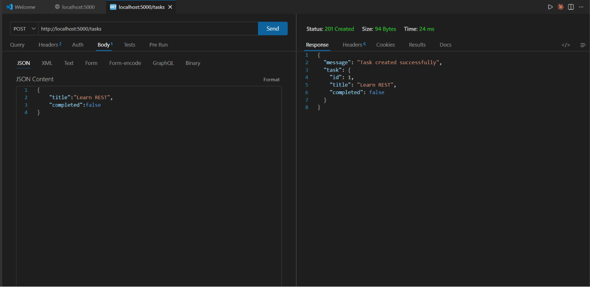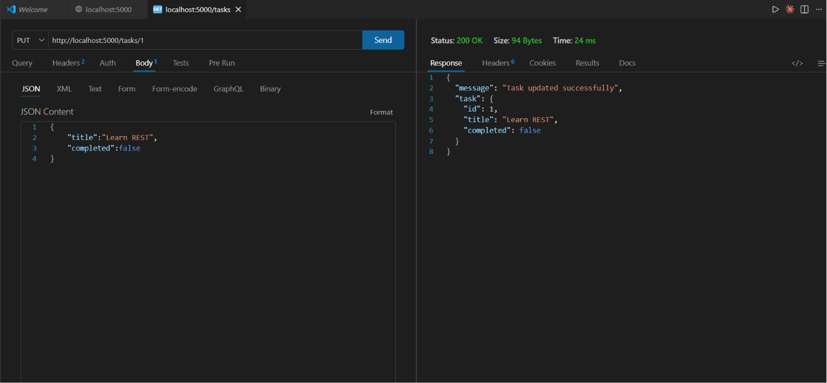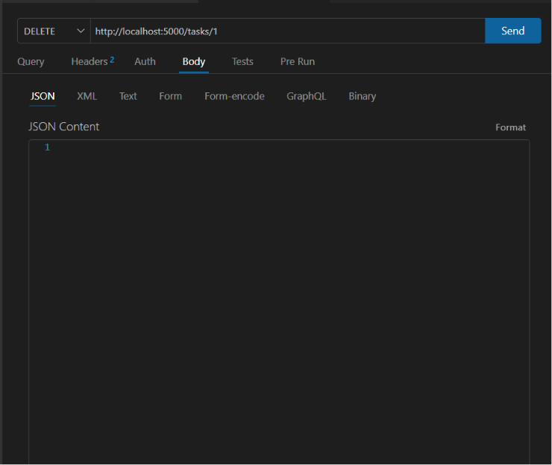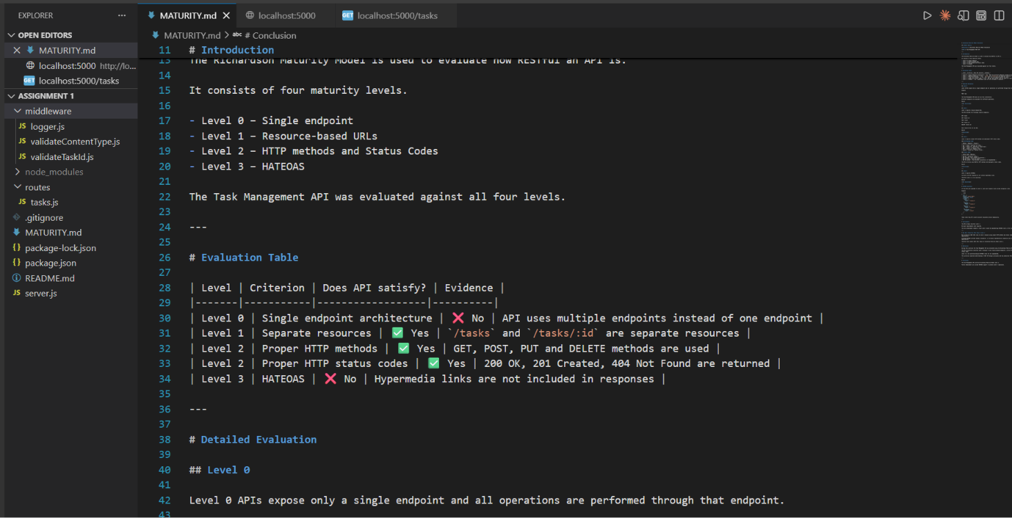

Github Repo Link:
https://github.com/digishasavaliya/ITUE301_AWDF.git

